Name – VISHWAS GOWDA DS
USN – 1BG24BA158
COURSE – AIML
TOPIC – SALES MANAGEMENT SYSTEM

1. Introduction
The Sales Management System is a Python-based console application designed to help small businesses and shops efficiently record, store, and analyze sales transactions.
Instead of maintaining sales details manually on paper, this system provides a structured and digital way to manage sales data with accuracy and reliability.
2. Problem Statement
Many small businesses still manage their sales records manually, which can lead to:
- Data loss
- Calculation errors
- Difficulty in tracking daily revenue
- Time-consuming record searching
- Poor sales analysis
3. Objectives
The main objectives of this project are:
- To develop a menu-driven sales management system
- To store sales records permanently using JSON file handling
- To perform automatic calculations of total sales and revenue
- To allow searching and filtering of sales data
- To generate sales statistics and analytics
- To improve efficiency and accuracy in sales record management

4. Technologies Used
Technology
Python
JSON
Datetime Module
File Handling
Console Interface

5. Modules and Function Description
5.1 Python Modules Used
- json
  - Used to save and load sales records from a file.
- datetime
  - Used to capture current date and time of each sale.
6. File Handling
The project uses JSON file handling for permanent storage.
File Used
- sales_data.json
Operations
- Read Mode (r) – Load existing sales data
- Write Mode (w) – Save updated sales records
7. Result and Output
Output Features
- Menu-driven interface
- Accurate calculation of:
  - Total amount per sale
  - Daily revenue
  - Overall revenue
- Well-formatted sales display
- Persistent storage of data
- Sales analytics and statistics

8. Conclusion
The Sales Management System is a reliable and efficient solution for managing sales records digitally.
It reduces manual work, minimizes errors, and provides meaningful insights into sales performance.
This project demonstrates:
- Effective use of Python fundamentals
- Proper file handling using JSON
- Use of functions, loops, dictionaries, and lists
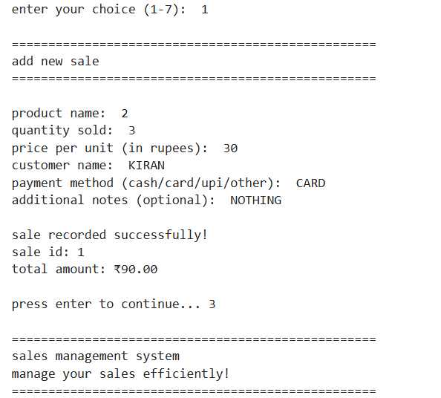
- Real-world application of programming concepts
